Youth Programming for Constellations of Place

For Educators:
Constellations of Place is an exhibit created in conjunction with the America 250-Colorado 150 Southwest regional “Power of Place” initiative. This initiative is intended to educate Coloradans on how our geography, climate, and culture impact our community and how we, in turn, influence those features. However, Constellations of Place is not a celebration of anniversaries; rather, it is an opportunity for visitors to look closely at how we understand place, memory, and belonging. It presents the diverse histories of the Four Corners region, bringing together different experiences and perspectives in a nonlinear fashion. Drawn from both the Center of Southwest Studies’ collections and contemporary Indigenous, Native American, and Latinx artists, the artworks in this exhibition remind us that survival is not passive, but an active practice of creation, adaptation, and care.

This programming will allow elementary-aged children to engage with these concepts in an accessible and meaningful way. Exhibit curator Dr. Meranda Roberts recognized that the people of Durango and the wider community want to learn about the histories of Indigenous, Native American, and Latinx communities. The exhibition offers non-Native visitors an opportunity to learn about these histories and experiences by approaching the artworks with openness, curiosity, and respect. All exhibit visitors are encouraged to experience “how art can become a map for truth-telling, repair, and renewed belonging” while reflecting on the exhibition themes and moving towards responsibility. Specifically, this program will guide students through reflection with these aspects of art in mind, culminating in one of two projects.

Students and educators can engage with this programming in the ways that they see fit. This document contains background and discussion questions for five artworks, thematic discussion questions, and two projects. Educators can cover all the content, or they can choose certain artworks and projects that they think would be most beneficial for their students.

For Students:
The Southwest: History and Constellations of Place
The following artworks are from the exhibit Constellations of Place at the Center of Southwest Studies. This exhibit explores different stories that make up the history of the Four Corners region. This year, the United States of America is celebrating its 250th anniversary, and Colorado is celebrating its 150th anniversary. However, there are many histories that began long before the United States became a country or Colorado became a state.

Indigenous peoples have lived in the Americas for thousands of years, long before Europeans
arrived. Over the past 500 years, European colonization and the expansion of the United States have profoundly affected Indigenous communities, cultures, and relationships to the land. Over time, new countries and states, including the United States and Colorado, were established on lands where Indigenous people had already lived for thousands of years. Karen focuses on the backstory of the women she makes art of, which can be viewed through their facial expressions, body postures, and clothing. This exhibit and programming look at how we understand ideas like place, memory, and belonging. It combines different histories into one larger story. As you look at the art, consider these three things: How does where we live, and our culture, affect our lives? How do we change our environment? How can art share stories and heal communities?

Important terms to know:
- Indigenous: Refers to the original peoples of a place and their descendants, who maintain connections to their ancestral lands, cultures, and communities.
- Native American: A term commonly used in the United States to describe Indigenous peoples and members of Tribal Nations whose ancestral homelands are in North America.
- Latinx: A gender-inclusive term used to describe people with cultural or family connections to Latin America. Other terms include Latino, Latina, and Latine.
- Hispanic: A term used to describe people with cultural or family connections to Spanish-speaking countries, particularly Spain and countries in Latin America.

Select Artwork from Constellations of Place:
Artwork can be viewed and discussed individually, in groups, or as a whole class. The following questions have been crafted for thoughtful contemplation. Responses to these questions can be thought about, discussed, used for think-pair-share, or written down.

Tips for how to look at art:
Taken from Advancing Arts Leadership
Step 1: Look Closely
  - What do you see?
  - Where do you see that?
  - What else do you notice?
  - Describe more details of what you are seeing.
Step 2: Think Carefully
  - What does it mean?
  - What can you guess about the people, places, or things in this picture?
  - What do you think the artist is trying to say?
  - What do you see that makes you say that?
  - What do YOU think it means?
  - What do you see that makes you say that?
Step 3: Judge Thoughtfully
  - Is it successful?
  - Why do you think the artist was successful or unsuccessful?
  - What do you see that makes you say that?
  - Do you like it? Why or why not?

The Wild Wild West
Karen Clarkson (Choctaw), The Wild Wild West, 2021. Oil on paper. Courtesy of Blue Rain Gallery.
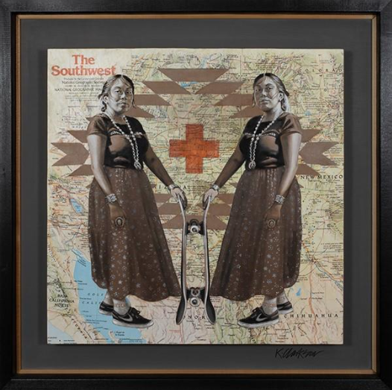

Background:
In this piece, Karen Clarkson depicts Naiomi Glasses (a skateboarding legend who often skates on her reservation) over a map of the Southwest. Naiomi is presented in traditional clothing, but with sneakers and a skateboard. She is depicted on top of a map of “The Southwest” and Indigenous patterning. This work shows how place, memory, and daily life inform Indigenous creativity.

Clarkson focuses on the personal histories of the women she depicts, using their facial expressions, body language, and clothing to communicate aspects of their identities. She also tries to show their determination, culture, and sense of purpose in her pieces. She explains that she wants to engage and inspire others while communicating our shared experiences as humans.

Questions:
- What do you see in this artwork?
- How does it make you feel?
- How does Clarkson combine both traditional Indigenous and contemporary elements?
- What information can you gather about Naiomi Glasses through this artwork? (Hint: Look at her outfit, facial expression, and what she is holding.)
- Why do you think Clarkson placed Naiomi on top of a map of the Southwestern corner of North America?
- What do you notice on this map? (Borders, land features, etc.). How might the borders on this map differ from the traditional homelands of Indigenous people?
Beaded Gauntlets
Artist Once Known (Ute), Beaded Gauntlets, n.d. Beaded buckskin.
CSWS permanent collection 1963:07007
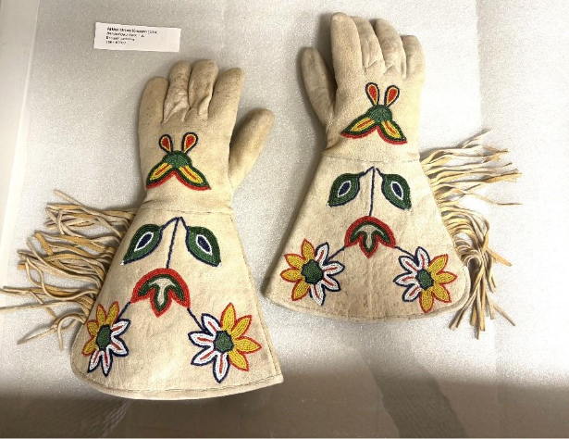

Background:
These Ute gloves are made from buckskin with beaded floral patterns and tassels. Many objects like these are in the Center of Southwest Studies’ collection because of Homer Emerson Root. Root recorded more than 1,200 objects during the 1950s and 1960s, including textiles, pottery, basketry, and beadwork. This process was consistent with how institutions like museums were trying to view Native life through a settler gaze.*

By taking these objects out of the places where they were made, they are disconnected from the stories that go along with them and the people that they belonged to. Museums and collectors have often documented Indigenous objects without consulting the
communities from which they originated. As a result, important information about these objects, including their histories, meanings, and cultural significance, has sometimes been lost or misrepresented.

*Settler gaze: A way of looking at Indigenous peoples, cultures, and lands from the perspective of settlers, often without fully understanding or respecting Indigenous histories, knowledge, or perspectives.

Questions:
- What do you see in this photograph?
- How does it make you feel?
- How does taking these gloves from where they came from change their story?
- What is an object you own that someone would not understand if you did not explain it to them?
- Why is it important for Indigenous communities to help decide how their cultural belongings are described, cared for, and shared?
Julia & Joslynn
Cara Romero (Chemehuevi), Julia & Joslynn, First American Doll series, 2018.
Archival pigment print. Courtesy of the artist.
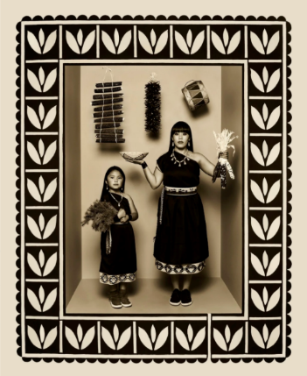

Background:
Romero uses photography to reject stereotypes so that you can see the diversity of Indigenous peoples. She brings both cultural traditions and 21st-century ideas and objects together to show you that a culture can be tied to its past and continuously evolving at the same time. Julia & Joslynn is part of a series called “First American Dolls,” in which people from different Tribal backgrounds showcase their regalia* and share different aspects of what it means to be a modern Native person. Julia is of Cochiti and San Ildefonso ancestry. She was photographed with her grandmother’s baskets and blue corn and her great-great-uncle’s drum. She also wanted the Cochiti bee weed/wild spinach design for her box.

*Regalia: A collection of items that combine traditional, historical, and modern aspects of identity. These items can reflect a wearer’s life, interests, family background, and personal tastes. Often, they can be family heirlooms or gifts made by family members.

Questions:
- What do you see in this photo?
- How does it make you feel?
- What aspects of Julia’s culture are displayed? How do these contribute to the meaning of the work?
- How do you think aspects of place influenced this photo? (Hint: Where do you think the different items came from)? Where do you think the spinach (for the spinach design) grows?
- If you created a portrait of yourself using objects that represent your identity, family, and community, what would you include?
Untitled (Woman on Horseback)
Gerald Nailor (Diné), Untitled (Woman on Horseback), 1950.
Serigraph. CSWS permanent collection 1989:12003
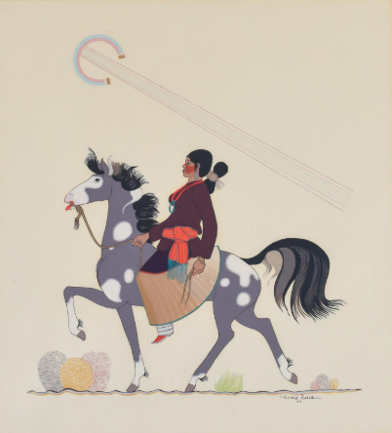

Background:
This artwork was rendered in flat style, one of the most famous 20th-century Native American artistic traditions. These works are known for their focus on form and outline. They also often used bright colors with less shading or perspective. This style influences many Indigenous artists today.

Flat-style painting developed during the early twentieth century and became associated with Native American art programs, including those at schools where Indigenous students were educated. Some of these schools were part of a larger system that sought to separate Native children from their families and cultures. Despite these circumstances, Indigenous artists used painting to express their identities, traditions, and creativity.

Questions:
- What do you see in this artwork?
- How does it make you feel?
- How is line used in this print? Why do you think flat style is known for having a focus on line?
- How is form used in this print? Why do you think flat style is known for having a focus on form?
- How is color used in this print?
- How can making art help people remember and express things that are important to them?

Kachina Song Blessings
Michael Kabotie / Lomawywesa (Hopi), Kachina Song Blessings, 1986.
Lithograph. CSWS permanent collection 1994:04010
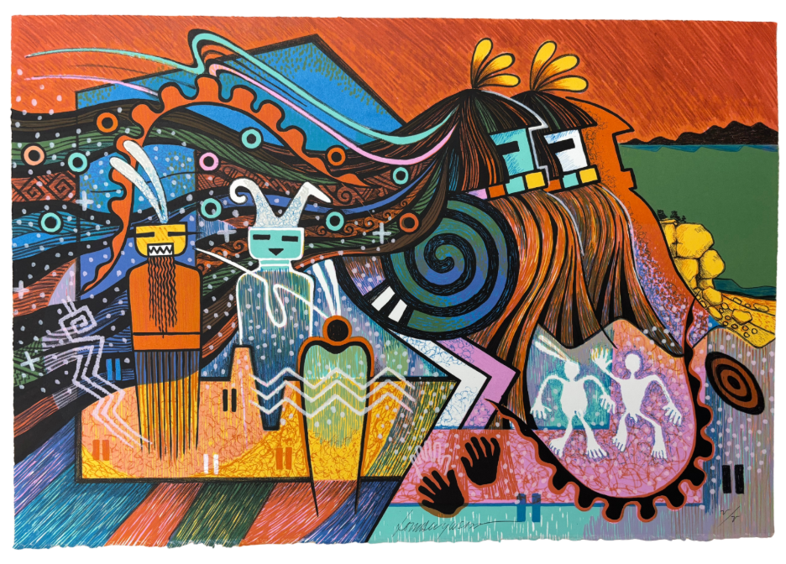
Background:
Michael Kabotie is an influential Hopi artist who combined traditional artistic forms with contemporary approaches to painting and printmaking. His work encourages viewers to think about how Indigenous cultures connect the past, present, and future. These pieces use traditional designs but transform them into new fantastical images that both honor the past and recognize the present, helping us “imagine otherwise.”

Questions:
- What do you see in this artwork?
- What forms (recognizable or not) can you find in this piece?
- How does it make you feel?
- How is color used?
- How would the piece be different if it were in black and white?
- What do you think it means to “imagine otherwise”?
- What is the world depicted like?

Thematic Discussion:
The following questions are starting points for a group discussion about the themes raised in Constellations of Place. Responses to these questions can be thought about, discussed, used for think-pair-share, or written down.

Questions:
- What did you know about the Southwest already?
- Did these artworks teach you anything new?
- What sort of histories are present in this place?
- Do you think people “carry” different histories?
- Do you hold your memories of places in your body? Where?
- How do your histories shape who you are?
- How have the places you’ve lived in shaped who you are?
- Have the items you own changed you? How have you changed them?
- How does the story of an object change when it is NOT told by the person from which the object came?
- How will you take what we discussed today forward?
- Is there something about the history of this place or these artworks that you want to discuss but we didn’t get to?

Project Option I: Visual Arts
Constellations of Place refers, in part, to the connection of stories that create the history of a place. Rather than forming a timeline, these stories come together to create a constellation that deals with them in a non-linear way. It connects them across cultures and times to show the image of what this place has been and can be. This project combines this idea of constellations with cartography, the science or practice of drawing maps.

Students will create a constellation of their own history by representing places, objects, and landscapes that are important to their identity. Using a variety of different sources (printed images, magazine cut-outs, drawn or painted pictures, or 3-D objects, which can be fun as well!), students will combine different aspects of themselves into one large map. The objects can be arranged like places on a map, stars in a constellation, or something more abstract.

Collages are a collection of stories and images combined on a visual plane. Each image comes from a wide range of sources that have different contexts: when they were made, where they are from, and what their goals were. Students will find and create representations of objects and places that matter to them by considering which aspects of place and identity are important to them; hopefully using concepts learned in class discussion to create an artwork that is an accumulation of personal stories.

Questions to help prompt creativity:
- Where did you grow up?
- What places are important to you? Are these landscapes, buildings, rooms, locations, etc.?
- Who/what else has lived there?
- What items or objects are important to you? Where are they from? When were they made?
- What or where has helped shape you into the person you are today?
Project Option II: Sound Studies/Sonic Art:
Constellations of Place not only presents the stories and histories of this region but also asks viewers to engage with the concepts of reflection and responsibility. It asks viewers to question how they impact the spaces around them. This project aims to help students work through these ideas in a simple, creative, and digestible way.

Students will participate in a listening exercise. They can do this exercise at home, bring in a recording from home, or just listen in the classroom or at school. Each location will have the students contemplating different aspects of responsibility in relation to place.

Students will take one minute to listen to a place. This can be done by sitting quietly and paying attention to the different sounds around them. They can be curious and let their minds wander about what a sound is, but after a few seconds, they should come back to just listening. After the listening session, students should take a few minutes to write down the answers to some of the questions below.

Questions:
- What sounds did you hear?
- What sounds did you recognize? Which ones did you not?
- Did you hear sounds that don’t normally happen?
- What sounds come from the environment? (Hint: trees rustling in the wind, an animal moving or talking, etc.)
- What sounds did humans create? (Hint: cars driving by, a clock ticking, pipes rumbling, etc.)
- What sounds are a direct result of something that you did? (Hint: Not just movements, the items that you put in that place. Did you put a fish tank in your room that always makes a bubbling noise? etc.)
- What noises are comforting?
- What noises are not?

